AWS Comprehend PII Job

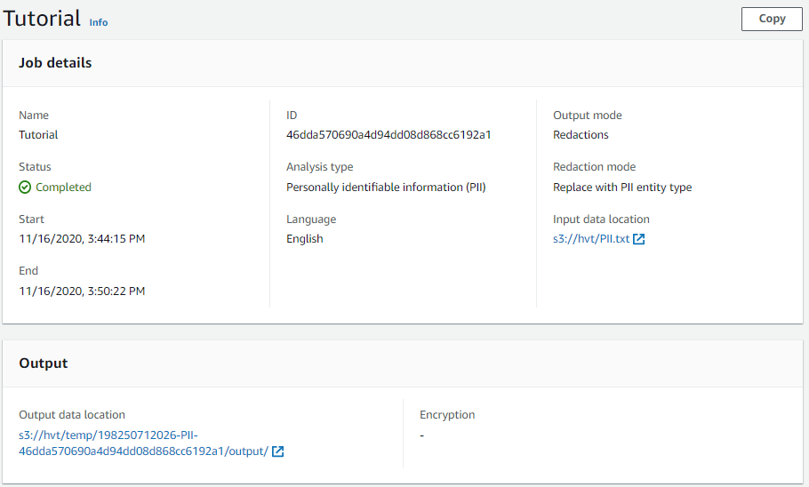  
Input of PII Job

 Output of PII Job   
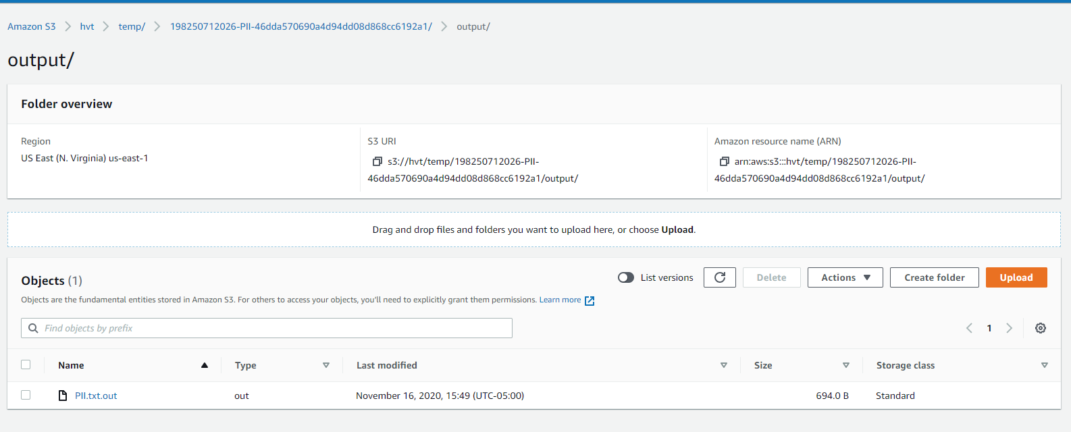

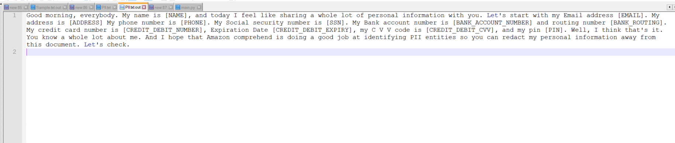

Presidio Analyze tested as python package

